Criticism: Poison or Elixir?
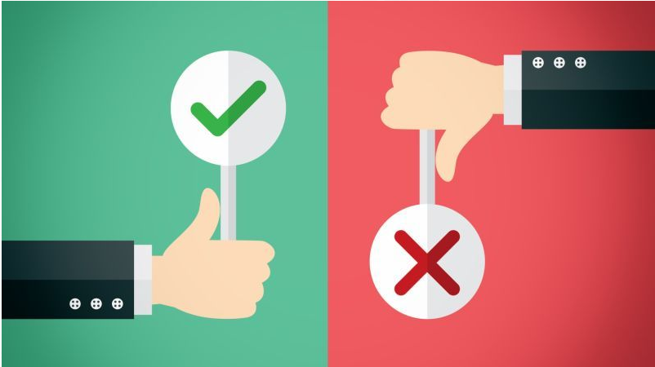

Pirkei Avos 6:6
...but the Torah is acquired by means of forty-eight qualities... loving reproofs...

Talmud, Arachin 16b
From where do we know that one who sees in one’s friend something repulsive [for example, a transgression] is obligated to give reproof [so that he can correct it]? As it is said: “Do not hate your brother in your heart. You must reprove your fellow, and do not bear a sin because of him.” [Vayikra 19:17].

The Hebrew word for reproof, positive criticism, “tochachah” is derived from the root which means “to prove” or “to demonstrate.”

Talmud, Yevamos 65b
And Rabbi Ilai said in the name of Rabbi Elazar the son of Rabbi Shimon: “Just as there is a Mitzvah for a person to say words of reproof that will be accepted, so too there is a Mitzvah for a person not to say words [of reproof] that will not be accepted.”
Rabbi Abba said: “It is not only a Mitzvah to refrain from speaking words of reproof that will be ignored, it is an obligation not to offer such words. As it says, ‘Do not reprove a scoffer, lest he hate you; reprove a wise man, and he will love you’ [Mishlei 9:8].”

Talmud, Arachin 16b
R’ Tarfon said: “I wonder if there exists anyone in this generation who knows how to accept reproof. For if one says to [his fellow nowadays], ‘Remove the splinter from between your eyes,’ [i.e. refrain from a minor infraction, his fellow] can retort, ‘Remove the beam from between your eyes’ [i.e. refrain from a major transgression]”
R’ Elazar ben Azaryah said: “I wonder if there exists anyone in this generation who knows how to give reproof.”
#1 Question: Why do people feel a need/urge to criticize, to try and improve others?

#2 Questions:
(a) Since people usually get offended when receiving criticism – should one refrain from it?
(b) Under which circumstances would it make sense to reprove someone?
(c) Is there a way to do it in a way that the person actually will want to improve?

#3 Question: How do you feel when you are getting positive criticism/ feedback?
Why?

#4
Talmud, Arachin 16b
Rabbi Yochanan ben Nuri said: “I call heaven and earth as my witness that many times [Rabbi] Akiva was rebuked harshly on account of me, for I used to complain about him to Rabban Shimon B’Rabbi and it only caused him to love me all the more, thereby fulfilling the verse, “Do not reprove a scoffer, lest he hate you; reprove a wise man, and he will love you” [Mishlei 9:8].

Pirkei Avos 6:6
...but the Torah is acquired by means of forty-eight qualities... loving reproofs...

Questions:
(a) What could be the reason for the Mishnah to say “reproofs” in plural?
(b) Why would someone love reproofs? Are we dealing with masochists? :)
(c) How can a person learn to not be offended by reproof, but to like and even love it?

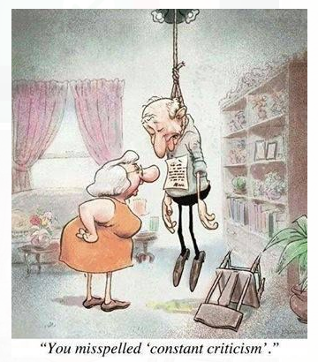
#5 Question: What's your takeaway from today's discussion?

